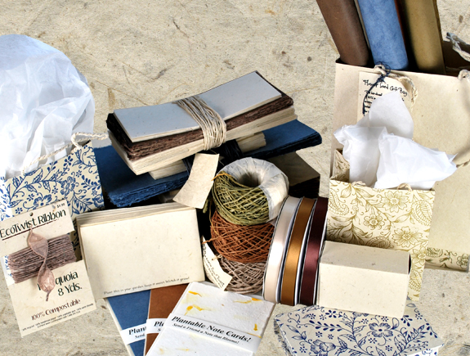

For Immediate Release

Vegetable Dyed Card and Wrapping Paper Line Blooms

In the heart of winter we hope you too are planning for spring. Our newest shoots have already sprouted.
This complete line of earth friendly items includes our newest papers and DIY cards that will bloom when planted.

Seattle, Washington (Of The Earth) December 11, 2008 – After five years percolating in the suburbs, Of The Earth has returned to Seattle ready to spring into another busy growing season with new seed paper offerings. With soil still under their fingernails the design team has brought out the best collection yet.

Compostable card and envelope sets designed to be printed at home are central to the new line. This paper (including the Eco-Twist ribbon) contains 50% recycled material, is tree free and has been dyed with natural vegetable dyes making them safe to plant in the ground. Doing so will produce a blend of 15 flowers that will bloom after a few weeks of care. Lotka paper begins as a plant much like a Laurel and regenerates from the root once harvested. Year after year the raw material is responsibly forested to ensure a healthy environment and continued resource. Imagine seeing seedlings germinating in an envelope that also acts as a weed block. These will naturally decompose without adding to landfills or using up resources being converted into recycled paper.

This earth friendly line includes our new light weight 20” x 30” wrapping paper in the vegetable dyed colors. We have named them Spruce, Sequoia, Hemlock and Aspen. Made from cutch, indigo, pomegranate, and walnut plants the irony of the paper names is intended to remind us of the trees being saved by making better paper choices.

Making an earth friendly product line has always been the goal and passion of Kevin and Lori Graham, founders of Of The Earth who in 1995 spun their love for each other into a successful handmade papermaking business where the desire to have a positive impact was metered out one sheet at a time. Of The Earth can be found online operating www.custompaper.com, www.flowerseedpaper.com, www.earthinvitations.com and www.wholesalesupplies.biz.

Valerie Robeck, General Manager
Of The Earth
206.462.7022
www.custompaper.com

