

1226 South Angelo St.
Seattle, WA 98108
Toll Free: 1.888.294.1526
Email: ote@custompaper.com
http://www.custompaper.com

Directions for constructing your invitations

Punching
Take one clear printed invitation overlay and center it on the flat card. Do this with the invitation face up flat on the edge of a table with the top edge of the invitation closest to you. Place the template (business card size with 2 holes at the top) flush with the top of the clear invitation insert (adjust as needed based on your print margins). Using a 1/8 inch diameter hole punch, punch through the invitation overlay and handmade paper using care to preserve the integrity of the template.

Organdy Ribbon Tying
You will need to cut the organdy ribbon to 6". Take one length of ribbon and pass both ends through the front of the invitation. Make sure that what is visible on the front is not twisted; this will be the center of the tie. Now make sure that the two lengths of ribbon poking out the back are equal. Cross them and pass them out the opposite holes that they came through. With a little twisting and tugging you will see them lay like the sample. Trim up the ends if they have frayed.

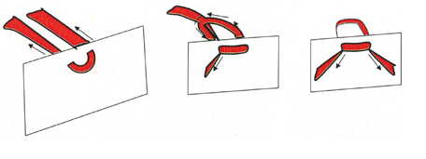

Envelope Stuffing
The invitation should be placed in the envelope facing the side with the flap, oriented with the top nearest the stamp. The enclosures should be behind the invitation. When putting your completed invitation in the envelope, use an extra response card to cover the attachment in order to slide it inside unharmed. Make sure to remove this extra response card every time. Prior to putting stamps on your envelopes take one complete invitation to the post office and have them weigh it for you to make sure you apply the correct postage amount.

