5”x7” Flat Panel with vellum overlay and Organza Ribbon French Tie
Tip: Please read through entire instructions first!
Materials: Flower Seed paper, vellum for overlay, and ribbon
Assembly tools used: bone folder, 1/8” hole punch, hole punch template

Tearing Panels:
- Place whole 18” x 24” sheet of Flower Seed paper on a clean, hard, flat surface.
- Place a 5” x 7” template over one corner of the sheet, (see template below). Score paper around template using a bone folder with gentle pressure. Repeat until you have ten outlines.
Tip: Stay within the 5x7 size or you might exceed the size of your envelope!
- To start tearing panels, fold the sheet along the longest score mark and crease firmly with bone folder. Be careful to not dent or gouge paper.
- Open up sheet and gently tear along the creased edge, making sure the tearing pressure is directed to only one point. Hold one folded side flat on the table, with the other side raised in the air. Control the direction of the tear by pulling gently toward yourself.
Tip: Construct one of your invitations completely when you have the first panel torn. You can double-check envelope fit, and final invitation before ALL your paper is torn.
- Continue to fold, crease and tear along each of the scored sections. You will end up with four small sections of extra paper and ten backing panels 5x7 invitations.

Punching Holes for ribbon:
- Take one clear invitation overlay (4.75” x 6.75”) and center it on one flat panel. Position them face up, flat on the edge of a table with the top edge of the invitation closest to you.
- Place the template (business card size with 2 holes at the top) flush with the top of the clear invitation insert. Punch through both the invitation overlay and backing panel with a 1/8” hole punch.

French Tie Ribbon Attachments (see illustration below):
For each invitation, you will need 6" of ribbon.
- Take one length of ribbon and pass both ends through the front of the invitation. Make sure ribbon visible in front is not twisted as this will be the center of the tie.
- Adjust the two lengths of ribbon so they are equal in length.
- Cross them and thread them through the opposite holes. With a little gentle adjustment, they will look like the examples on our website. Trim and neaten edges.
Tip: Don’t make the knot too thick or it may have difficulty going through the mail!
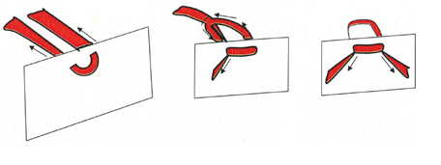

Putting Invitations into Envelopes:
Tip: Use an extra response card to cover the attachment so you can slide it inside the envelope unharmed. Remove this extra response card every time!
The invitation should be the first thing your guest sees upon opening the envelope. Place the invitation in the envelope facing the side with the flap, oriented with the top nearest the stamp. Put all enclosures behind the invitation, with everything facing the back flap, starting with the invite and ending with the smallest item on the bottom of the stack. The response card should be tucked under the flap of its response envelope, not put inside.

